Register

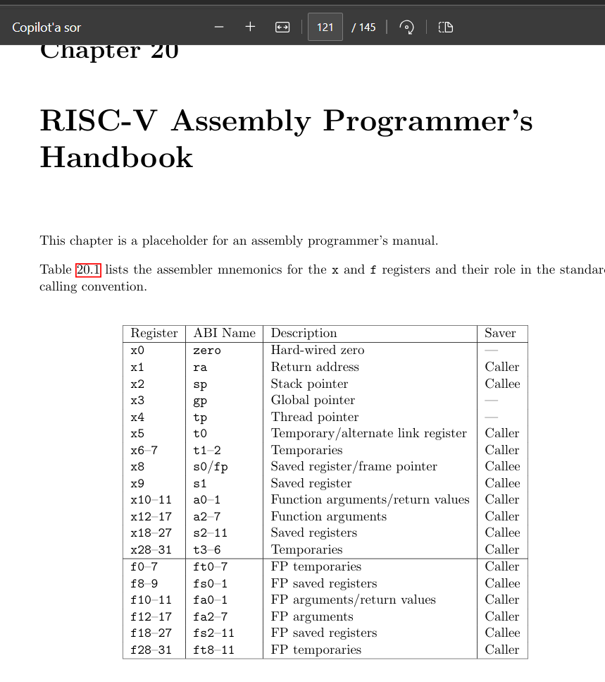

Instruction assembler pseudoinstruction

RV32I Base Instruction set

